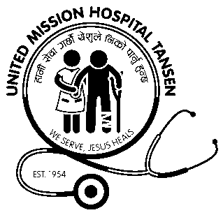  UNITED MISSION HOSPITAL  TANSEN  A Project of the United Mission to Nepal  Medical and Development Trust |  | 
Job Description
Job title: IT Consultant
Level : 10-11
Responsible to: Hospital Director
Relationship with: Computer officer, Hospital administrative officer
Qualifications and experience:
Master level (or above) in a relevant IT related field with a minimum of 5 years working experience.
Experience of working with hospital systems would be an advantage.
Experience server administration, server backups an advantage.
Experience with database systems an advantage.
Experience with web services an advantage.
Experience with Linux (Ubuntu Server) an advantage.
Experience with networks and firewalls an advantage.
Overall purpose of job (Job Summary)
To provide technical advice to United Mission Hospital, Tansen concerning procurement and use of IT systems. To develop appropriate training materials and programmes for national staff in conjunction with other organisations. As time permits to continue to help and advise other NCHA hospitals and mission organisations to develop their IT systems.

Work Traits
To take initiative
To be visionary and innovative
Ability to work in team
Ability to work under pressure
Ability to teach/train others
Duties :
- To work in the IT department in an advisory capacity.
- Mentor and support the hospital computer officer(s) and develop the department further.
- Analyse data from existing IT systems to improve availability of management information.
- To be responsible for overseeing the maintenance of the whole hospital computer, server, network.
- Advice and input for the choice of new equipment and software.
- Respond to IT emergencies as needed.
- Oversee the security of our computer systems from viruses hacking and other damage.
- Teach /train and guide other staff.
- Assist with budgeting and planning for the year and future needs.
- Other duties as may be required by the line manager.

